Flask + MongoDB Atlas Assignment
1. Objective
To create a Flask API that returns JSON data and a frontend form that stores user data in MongoDB Atlas with success and error handling.
2. Flask API Implementation
Created /api route which reads data from data.json and returns JSON response. 3. Frontend Form Implementation
HTML form collects name and email and sends POST request to backend.
4. Code Implementation
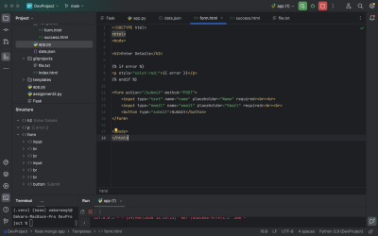5. Form Page
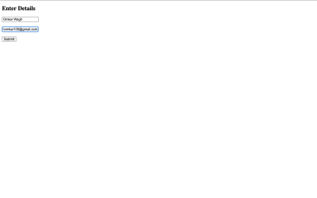
6. Success Page
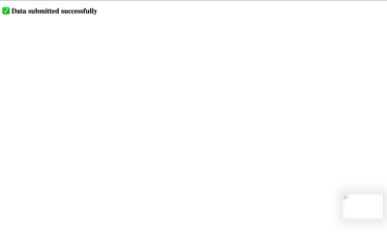7. MongoDB Data
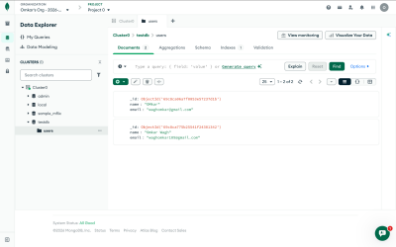8. GitHub Repository
Repository Link: https://github.com/OmkarWagh2003/linux-basics-assignment 9. Conclusion
The Flask API works correctly, form submits data successfully, MongoDB stores the data, and success/error handling is implemented.

